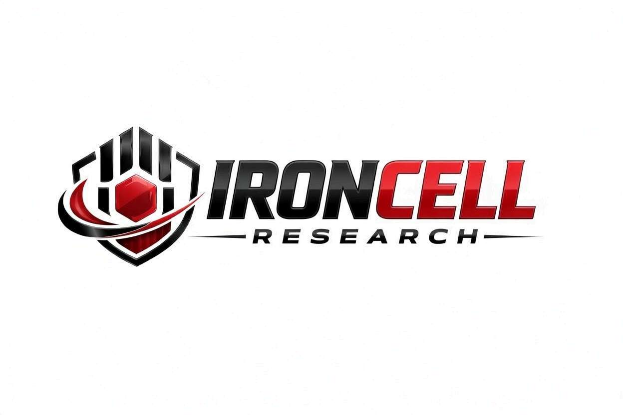
PEPTIDE RESEARCH BRIEF
Melanotan I
Synthetic Linear α-MSH Analog | MC1R-Selective Agonist

Description, Benefits, Dosage & Research Overview

Iron Cell Research
IronCellResearch.com
For Research Use Only


Compound Overview
Compound Name | Melanotan I (Afamelanotide / NDP-α-MSH)
Classification | Synthetic Linear Tridecapeptide / MC1R-Selective Agonist
Amino Acid Sequence | Ac-Ser-Tyr-Ser-Nle-Glu-His-D-Phe-Arg-Trp-Gly-Lys-Pro-Val-NH2
Molecular Formula | C78H111N21O19
Molecular Weight | 1646.85 g/mol
CAS Number | 75921-69-6
Biological Half-Life | Approximately 30 minutes (IV); 2-3 hours (depot/SubQ)
Purity | Greater than or equal to 99%
Storage | Lyophilized, -20C, protected from light
Research Status | Approved (Scenesse) for erythropoietic protoporphyria; ongoing research

Description
Melanotan I (afamelanotide, NDP-α-MSH) is a synthetic linear analog of alpha-melanocyte-stimulating hormone (α-MSH). Developed at the University of Arizona, it retains the linear backbone of native α-MSH but features two key modifications — Nle⁴ and D-Phe⁷ — that increase metabolic stability and prolong receptor binding compared to endogenous α-MSH.
Unlike its cyclic counterpart Melanotan II, Melanotan I is selective for the melanocortin-1 receptor (MC1R), the primary driver of eumelanin synthesis in melanocytes. This selectivity supports a cleaner pigmentation profile with substantially fewer off-target effects on appetite, sexual function, or autonomic tone. Marketed as Scenesse for erythropoietic protoporphyria (EPP), it remains the only melanocortin agent approved for clinical photoprotection.

Mechanism of Action

MC1R Selective Activation
Melanotan I is a high-affinity, MC1R-selective agonist. Activation of MC1R on melanocytes raises intracellular cAMP, activating CREB and upregulating MITF — the master transcription factor for melanocyte pigmentation. The resulting eumelanin provides robust photoprotection with minimal MC3R/MC4R/MC5R cross-reactivity at typical research doses.

Eumelanin Synthesis
MC1R signaling drives a shift toward eumelanin production over pheomelanin. Eumelanin is more photoprotective and absorbs a broader UV spectrum, while pheomelanin synthesis generates reactive oxygen species under UV exposure. This pigment-shift is central to MT-I's photoprotective profile.

Photoprotection & DNA Repair
Beyond pigment production, MC1R activation in keratinocytes upregulates nucleotide excision repair pathways and antioxidant defenses, helping mitigate UV-induced DNA damage. These effects underpin clinical use in EPP, where photosensitivity reflects defective heme biosynthesis and protoporphyrin accumulation.

Receptor Selectivity
Melanotan I shows substantially weaker activity at MC3R, MC4R, and MC5R relative to MC1R. At research doses this selectivity translates to a cleaner profile — without the broad appetite-suppression, autonomic, or sexual-function effects characteristic of pan-melanocortin agonists like MT-II.

Research Benefits

Skin Pigmentation & UV Protection
- Eumelanin Production: Selectively increases eumelanin synthesis in melanocytes, producing visible darkening with minimal UV exposure required.
- Photoprotection: Increased eumelanin density provides broad-spectrum UV protection; clinically significant in EPP and photosensitive populations.
- Pigment Profile: Eumelanin-favoring pigment shift may reduce oxidative DNA damage associated with pheomelanin pathway dominance.

EPP & Photosensitivity Disorders
- Erythropoietic Protoporphyria: FDA- and EMA-approved (Scenesse) for adults with EPP, increasing pain-free light exposure and quality of life.
- Polymorphic Light Eruption: Investigated in PLE and other photosensitivity disorders where eumelanin reinforcement may reduce symptom burden.
- UV Sensitivity: Researched for utility in fair-skinned populations and Fitzpatrick types I-II at elevated UV-related risk.

Cosmetic & Aesthetic Research
- Tanning Response: Produces darkening of skin pigmentation with substantially reduced cumulative UV exposure required to achieve a tan.
- Even Pigmentation: MC1R-driven pigmentation tends toward more uniform distribution than UV-stimulated tanning alone.
- Tone Retention: Pigmentation persists longer than UV-induced tan due to sustained eumelanin synthesis during dosing window.

MC1R Signaling Effects
- Antioxidant Defense: MC1R activation upregulates antioxidant enzymes in keratinocytes and melanocytes, reducing UV-induced oxidative stress.
- DNA Repair Support: Promotes nucleotide excision repair pathways implicated in repair of UV-induced cyclobutane pyrimidine dimers.
- Inflammation: MC1R signaling has been associated with modulation of local cutaneous inflammatory responses.

Dosage & Administration
The following dosage information is provided for research reference purposes only. Melanotan I is for laboratory research use only and is not intended for human consumption.
Protocol | Dose Range | Route | Frequency
Initial / Titration | 0.5-1 mg | SubQ Injection | Daily x 3-5 days
Loading Phase | 1-2 mg | SubQ Injection | Daily x 2-3 weeks
Maintenance | 1-2 mg | SubQ Injection | 2-3x per week
Long-Term | 1 mg | SubQ Injection | 1-2x per week

Reconstitution Guidelines
Solvent | Sterile bacteriostatic water
Reconstitution | 1-2 mL BAC water per 10 mg vial
Mixing | Gently swirl until dissolved, do not shake
Storage | Refrigerate at 2-8C, use within 30 days
Injection Site | Subcutaneous (abdomen preferred), rotate sites
Timing | Evening administration may reduce nausea
Note: Starting with lower doses during titration helps assess tolerance and minimize nausea.

Safety Profile
Melanotan I (afamelanotide) has been studied clinically and in research with the following considerations:
- Nausea: Less common than with MT-II due to MC1R selectivity; transient when reported.
- Facial Flushing: Possible transient flushing within 30 minutes of injection.
- Tanning Response: Significantly less appetite suppression than MT-II owing to weak MC4R activity.
- Mole Changes: Darkening of existing pigmented lesions; periodic dermatological monitoring recommended during use.
- Fatigue: Mild drowsiness reported in a minority of subjects.
- Cardiovascular: Generally well tolerated; minor heart rate or blood pressure changes occasionally reported.
- Contraindications: Personal or family history of melanoma or atypical mole syndrome. Active hepatic or renal disease per Scenesse labeling. Pregnancy not recommended.

Key References
- Lim HW, Grimes PE, Agbai O, et al. Afamelanotide and narrowband UV-B phototherapy for the treatment of vitiligo. JAMA Dermatology. 2015;151(1):42-50.
- Langendonk JG, Balwani M, Anderson KE, et al. Afamelanotide for Erythropoietic Protoporphyria. New England Journal of Medicine. 2015;373(1):48-59.
- Minder EI, Schneider-Yin X, Steurer J, Bachmann LM. A systematic review of treatment options for dermal photosensitivity in erythropoietic protoporphyria. Cellular and Molecular Biology. 2009;55(1):84-97.
- Hruby VJ, Wilkes BC, Hadley ME, et al. α-Melanotropin: the minimal active sequence in the frog skin bioassay. Journal of Medicinal Chemistry. 1987;30(11):2126-2130.
- Sawyer TK, Sanfilippo PJ, Hruby VJ, et al. 4-Norleucine, 7-D-phenylalanine-α-melanocyte-stimulating hormone: a highly potent α-melanotropin with ultralong biological activity. PNAS. 1980;77(10):5754-5758.
- Wolgemuth A, Caccavale L, Sanfilippo P. Afamelanotide: an evidence-based review of its clinical utility in the treatment of erythropoietic protoporphyria. Drug Design, Development and Therapy. 2020;14:213-226.
- Cone RD. Studies on the Physiological Functions of the Melanocortin System. Endocrine Reviews. 2006;27(7):736-749.

Contact & Information
Company | Iron Cell Research
Website | IronCellResearch.com
Email | orders@ironcellresearch.com
Product Support | Available via website contact form

Disclaimer
This document is intended for informational and research purposes only. Melanotan I is sold as a research compound and is not intended for human consumption. The information provided herein does not constitute medical advice, diagnosis, or treatment recommendations. All research applications should comply with applicable institutional, local, and federal regulations. Iron Cell Research makes no claims regarding the therapeutic efficacy of Melanotan I for any medical condition. Researchers should consult with qualified healthcare professionals and institutional review boards before initiating any research protocols involving human subjects.
Iron Cell Research - For Research Use Only


